**SACRED HEART GIRLS’ COLLEGE**

**OAKLEIGH**



**Mathematical Methods CAS 2013**

**Unit 3 SAC 1: TEST**

**Part A**

**Name: ________________________________**

**Teacher (please circle)**: Ms Gates Mr Smith Mrs Mak

**No CAS and no summary notes permitted**

**Part A: 5 short answer questions**

**Writing Time: 25 minutes**

**Marks: 19**

**SHORT ANSWER QUESTIONS**

**Instructions:**

Answer **all** questions in the spaces provided.

In all questions where a numerical answer is required an exact value must be given unless otherwise specified.

In questions where more than one mark is available, appropriate working **must** be shown.

Unless otherwise indicated, the diagrams in this test are **not** drawn to scale.

**Question 1**

1. State the sequence of transformations required to change $f\left(x\right)=x^{\frac{1}{3}}$ into $g\left(x\right)={2x}^{\frac{1}{3}}+3.$

The graph of the curve of $g(x)$ is shown below.

1. Sketch the curve of $g^{-1}(x)$ on the same set of axes below.

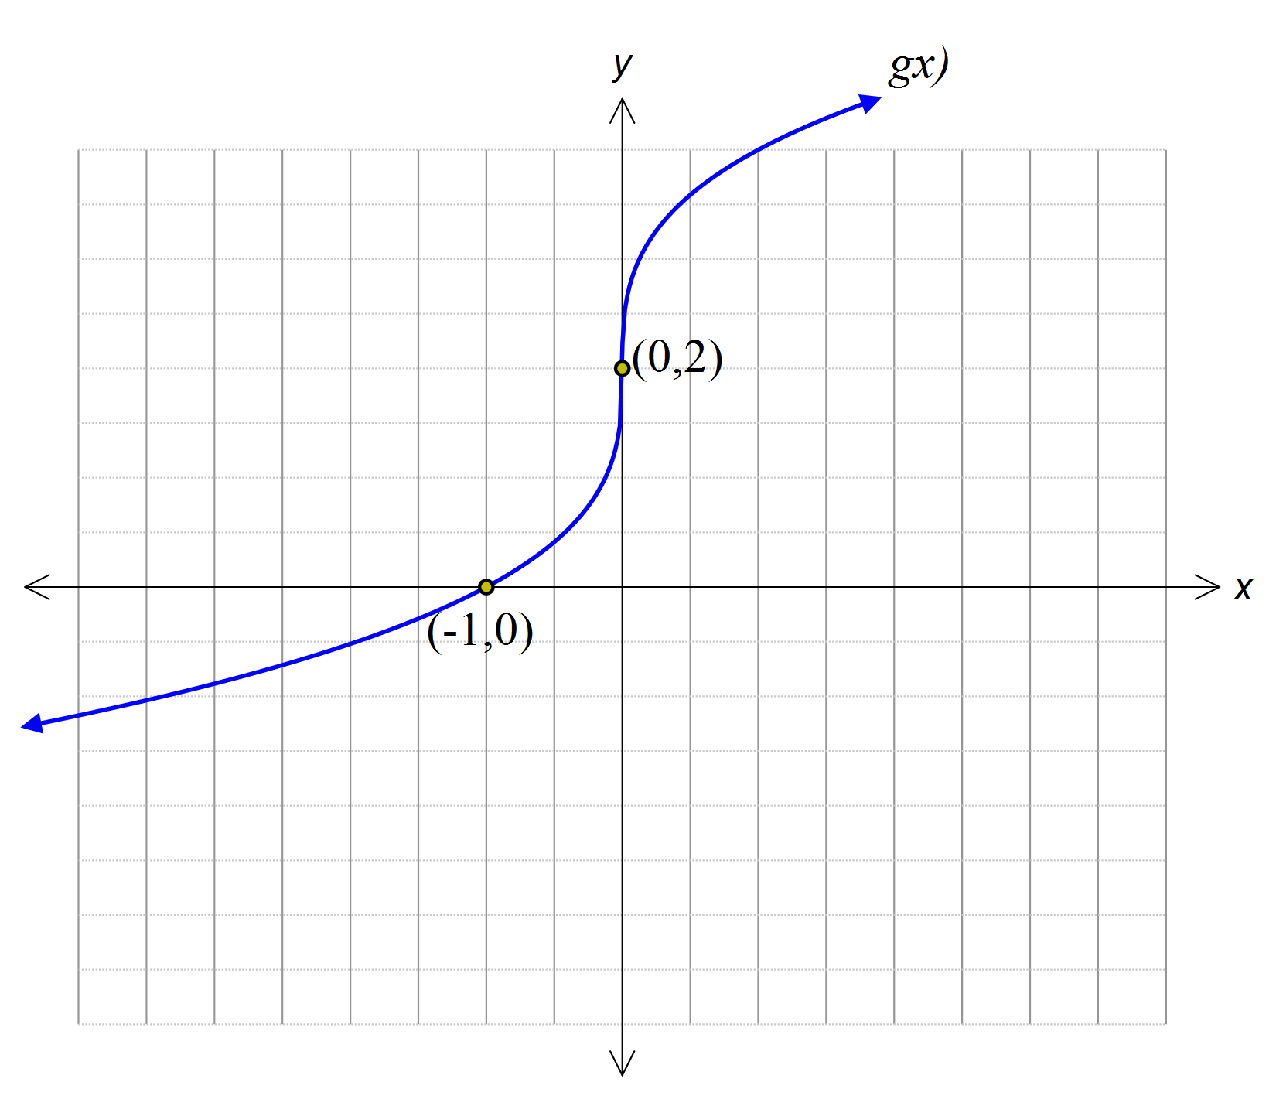

2+3=5 marks

**Question 2**

The transformation $T:R^{2}→R^{2}$ is defined by

$$T\left(\left[\begin{matrix}x \\ y\end{matrix}\right]\right)=\left[\begin{matrix}2 & 0 \\ 0 & 5\end{matrix}\right]\left[\begin{matrix}x \\ y\end{matrix}\right]+\left[\begin{matrix}2 \\ -3\end{matrix}\right]$$

The image of the curve $y=4x^{2}-1$ under the transformation $T$ has equation $y=ax^{2}+bx+c.$

Find the values of $a,b$ and $c.$

3 marks

**Question 3**

1. Show that $f\left(x\right)=\frac{x+3}{x-2}+1$ is equal to $f\left(x\right)=\frac{5}{x-2}+2$.
2. Hence, find the rule for the inverse of $f\left(x\right)$.

1+2=3 marks

**Question 4**

On the set of axes below, sketch the graph of the function $f$ with rule $\left(x\right)=\left|4+\frac{2}{x+2}\right|$. .

Label axes intercepts as coordinates and asymptotes with their equations.

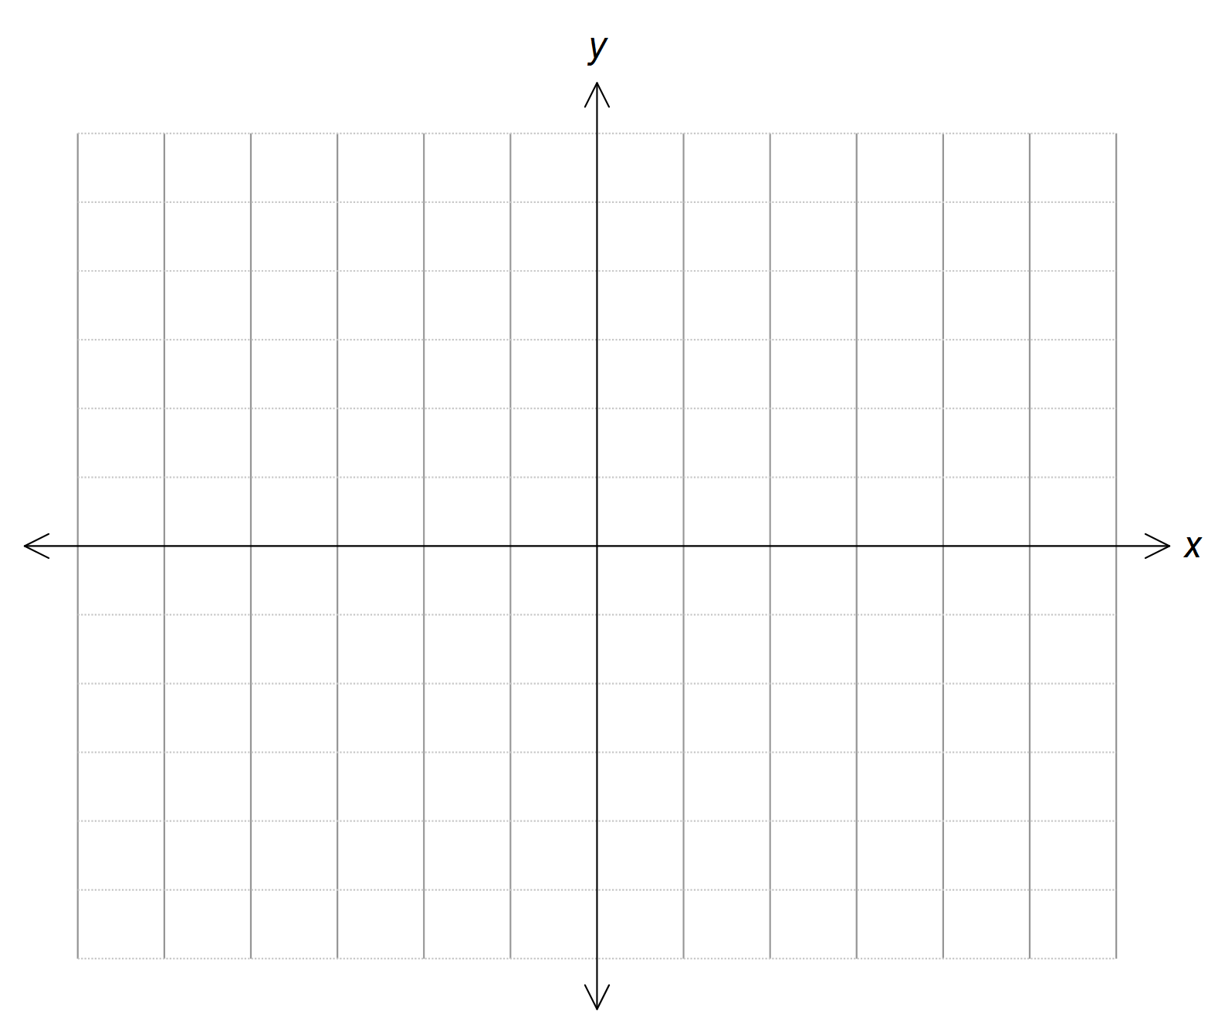

4 marks

**Question 5**

Let $f\left(x\right)=2x+1$ and $g\left(x\right)=2\sqrt{x}$.

1. Write down the rule of $f\left(g\left(x\right)\right).$
2. State the maximal domain for $f\left(g\left(x\right)\right).$
3. Evaluate $f\left(g\left(75\right)\right).$

1+1+2=4 marks

**SACRED HEART GIRLS’ COLLEGE**

**OAKLEIGH**



**Mathematical Methods CAS 2013**

**Unit 3 SAC 1: TEST**

**Part B**

**Name: ________________________________**

**Teacher (please circle)**: Ms Gates Mr Smith Mrs Mak

**Part B: 6 multiple choice questions and 2 extended response questions.**

**CAS and a bound reference of summary notes permitted**

**Writing Time: 35 minutes**

**Marks: 21**

**MULTIPLE CHOICE**

**Instructions:**

Answer **all** questions in pencil on the answer sheet provided for multiple-choice questions.

Choose the response that is **correct** for that question.

A correct answer scores 1, an incorrect answer scores 0.

Marks will **not** be deducted for incorrect answers.

No marks will be given if more than one answer is completed for any question.

**Only the answers on the Answer Sheet will be marked.**

**Question 1**

M (1,1) is the midpoint between the points A $(-$ 2,3) and B (*x,y*). The coordinates of the point B are

$\left(-\frac{1}{2},2\right)$

$\left(\frac{1}{2},-2\right)$

$\left(-5, 5\right)$

$\left(3, 5\right)$

$\left(4,-1\right)$

**Question 2**

The function $f(x)=x^{4}-3x^{3}+kx^{2}+4$ has one real solution when

$k=2$

$k=1$

$k<1$

$k>2$

$1<k<2$

**Question 3**

Considering the two functions $f\left(x\right)=\frac{1}{\sqrt{x-2}}$ and $g\left(x\right)=\sqrt{4-x}$. If $h\left(x\right)=g(f\left(x\right))$ then the domain of $h\left(x\right)$ is

$[2,∞)$

$(-∞,0)$

$(-∞,2)$

$(-∞,4]$

$(2,∞)$

**Question 4**

In order for $f\left(x\right)=2(x-2)(x-1)(x+5)$ to have an inverse function the domain could be

$[-5,-2]$

$[-2,-1]$

$[-5,-1]$

$[ 1, 5]$

$R$

**Question 5**

The maximum value of $f:\left[-2,4\right)→R, f\left(x\right)=9-{(\left|x\right|-3)}^{2}$ is

1. 8
2. 4
3. 3
4. 9

$∞$

**Question 6**

For the system of simultaneous linear equations

$$x+2y-z=2$$

$$2x+5y-\left(a+2\right)z=3$$

$$-x+\left(a-5\right)y+z=1$$

The values of *a* for which there is a unique solution are

1. 0 and 3
2. [0,3]
3. *R*\ [0,3]
4. *R* \ {0,3}
5. *R* \ (0,3)

**EXTENDED RESPONSE**

**Instructions:**

Answer **all** questions in the spaces provided.

In all questions where a numerical answer is required an exact value must be given unless otherwise specified.

In questions where more than one mark is available, appropriate working **must** be shown.

Unless otherwise indicated, the diagrams in this test are **not** drawn to scale.

**Question 1**

Two straight lines meet at right angles. The equation of the line $y_{1}$ is $y_{1}=\frac{x}{2}$

The line $y_{2}$ passes through the point $\left(10,0\right).$

1. Show that the equation of the line $y_{2}$ is $y_{2}=-2x+20$.

2 marks

1. Sketch the line $y_{2}$ on the axes below.

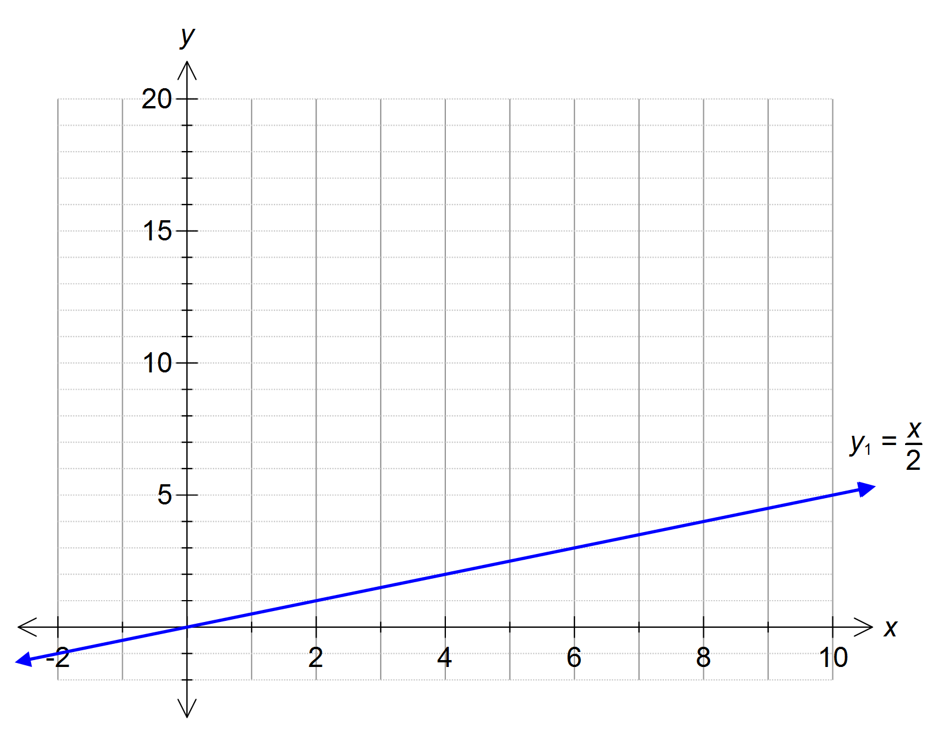

1 mark

1. Find the coordinates of the point of intersection of the two lines.

1 mark

Now consider the more general case where the first line has an equation of

$y_{1}=ax$ where $a$ is a positive constant.

The second line has an equation in the form of

$y_{2}=bx+c$ where $b$ and $c$ are constants.

The lines are still perpendicular and the second line still passes through the point $\left(10,0\right).$

1. Find an expression for $b$ in terms of $a$.

1 mark

1. Find an expression for $c$ in terms of $a$.

1 mark

1. Show that the value of the $x$ coordinate of the point of intersection of these two lines is

$$x=\frac{10}{a^{2}+1}$$

2 marks

1. Find an expression for the value of the y coordinate.

1 mark

Total 9 marks

**Question 2**

Dorothy Smart, the environmentalist, has received an emergency call about an oil spill in Bass Strait. The oil is forming a circular oil slick and the area of the oil slick is given by the function

$$A:\left[0,b\right)→R, A\left(r\right)=πr^{2}$$

where *r* is the radius in km and *A* is the area in km2.

Dorothy and her team need to contain the spill before it covers an area of 1200 km2 or it will reach environmentally sensitive areas of the region.

1. Find the value of *b*.

1 mark

In order to determine the spread of the oil slick over time Dorothy defines the function

$$r:R^{+}→R, r\left(t\right)=4t^{\frac{2}{3}}$$

where *r* is the radius in km and *t* is time in days.

She attempts to perform the composition *A(r(t))* only to find it does not exist.

1. Explain why the composite function *A(r(t))* does not exist.

1 mark

1. Define a restriction *r\** such that *A(r*(t))* is defined.

2 marks

1. Find *A(r*(t))*.

1 mark

1. Find the maximum number of days, to the nearest day, Dorothy and her team have to clean up the spill before serious and irreversible damage occurs to the environment.

1 mark

Total 6 marks

END OF SAC